**DAILY ONLINE ACTIVITIES SUMMARY**

|  |  |  |  |  |  |  |  |  |
| --- | --- | --- | --- | --- | --- | --- | --- | --- |
| **Date:** | **18-05-2020** | | | | | **Name:** | **Latika Kavoor** | |
| **Sem & Sec** | **4th Sem & A-Section** | | | | | **USN:** | **4AL18CS035** | |
| **Online Test Summary** | | | | | | | | |
| **Subject** | | **Engineering Maths** | | | | | | |
| **Max. Marks** | | **30** | | **Score** | | | **4** | |
| **Certification Course Summary** | | | | | | | | |
| **Course** | **Introduction to Cyber Security** | | | | | | | |
| **Certificate Provider** | | | **ICT Academy - CISCO** | | **Duration** | | | **30 hrs** |
| **Coding Challenges** | | | | | | | | |
| **Problem Statement:**   1. Hint: An Anagram of a string is another string that contains same characters, only the order of characters can be different. For example, "act" and "cat" are anagram of each other. 2. Write down a java program to print even and odd numbers series respectively from two threads: t1 and t2 synchronizing on a shared object Let t1 print message “ping — >” and t2 print message “,—-pong”.   Take as command line arguments, the following inputs to the program: Sleep Interval for thread t1 Write down a java program to print even and odd numbers series respectively from two threads: t1 and t2 synchronizing on a shared object  Let t1 print message “ping — >” and t2 print message “,—-pong”.  Take as command line arguments, the following inputs to the program: Sleep Interval for thread t1 Sleep Interval for thread t2 Message per cycle No of cycles | | | | | | | | |
| **Status: Completed** | | | | | | | | |
| **Uploaded the report in Github** | | | | | **Yes** | | | |
| **If yes Repository name** | | | | | <https://github.com/Latika31/lockdown-coding> | | | |
| **Uploaded the report in slack** | | | | | **Yes** | | | |

Online Test Details: (Attach the snapshot and briefly write the report for the same)

Maths test was conducted from 9:30-10:00

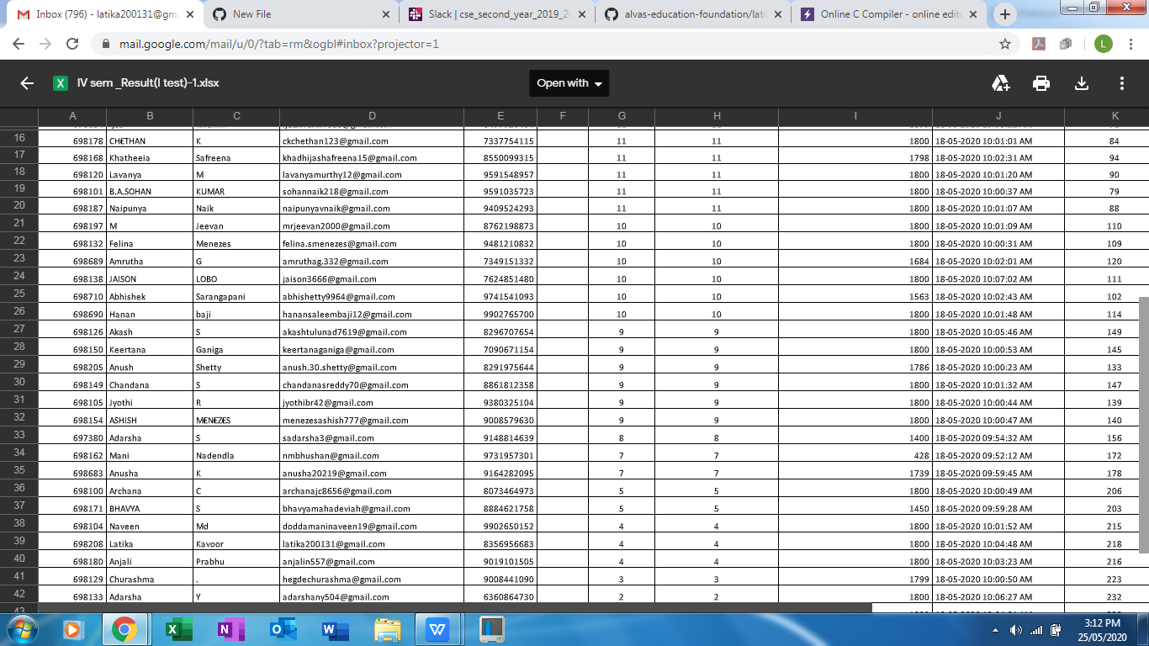

Certification Course Details: (Attach the snapshot and briefly write the report for the same) ----- I started with Cybersecurity Certification Course-the Introduction part of it provided by ICT Academy 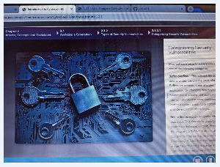

Coding Challenges Details: (Attach the snapshot and briefly write the report for the same)

Solved 2 problems and uploaded on github 